**The Vertical Alignment Design of Roundabouts**

R. Stockdale, BTech, MICE, MIHE

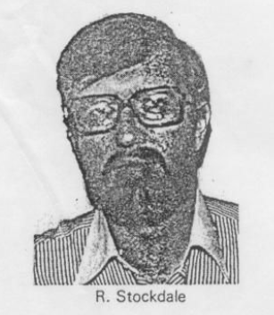The Journal of the Institution of Highway Engineers

(August/September 1978)

Biography

Mr Stockdale graduated from Bradford University in 1968. He has worked for Tarmac Civil Engineering Ltd, in the Planning and Programming Department and as a site engineer. He was then employed by Darlington BC in the Capital Works Section, working on the design and supervision of construction of several urban road schemes.

Summary

The method described in this Paper revises the philosophy of the vertical design of roundabouts. It simply, by persuading the engineer to present the information in a particular way, makes the ramifications of any of his design decisions patently clear. It cannot solve “impossible” vertical alignment problems but at least the engineer can minimise the sub-standard elements and he can make a rational decision as to which of his design standards must be compromised. Although the method described is manual, it lends itself easily to computer-based design systems.

Introduction

Vertical alignment design of roundabouts always presents problems and traditional methods of design are often inadequate, especially when small diameter roundabouts are under consideration. The Paper describes a design scheme based upon traditional methods which has been shown to be satisfactory, especially in difficult situations, for all types of roundabout with any number of legs.

The crown lines discussed are not necessarily the highest points on the cross-section of a given piece of road. They are imaginary lines which usually indicate a change in the degree of crossfall across a road and are the lines that surfacing equipment will work to during construction. It is assumed that the horizontal layout has been finalised (Figure 1a) and that the levels of all the entry and exit roads are known, in the case of existing roads, or have been provisionally designed in the case of proposed roads.

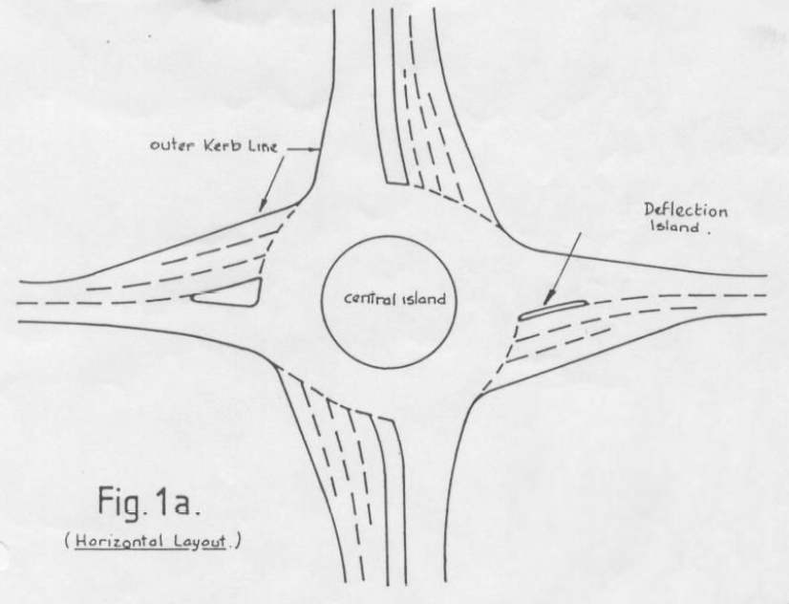

Horizontal Design of Crown Profiles

Using a layout plan of 1/500 scale or larger, allocate two letters to each leg (entry or exit roads) and pencil in the “inscribed circle”. This need not be a circle but should be a smooth shape which touches each of the outer kerb lines of the roundabout. Deflection islands should be ignored at this stage. The roundabout crown line can now be drawn as a line approximately two-thirds of the distance between the central island and the inscribed circle (Figure 1b).

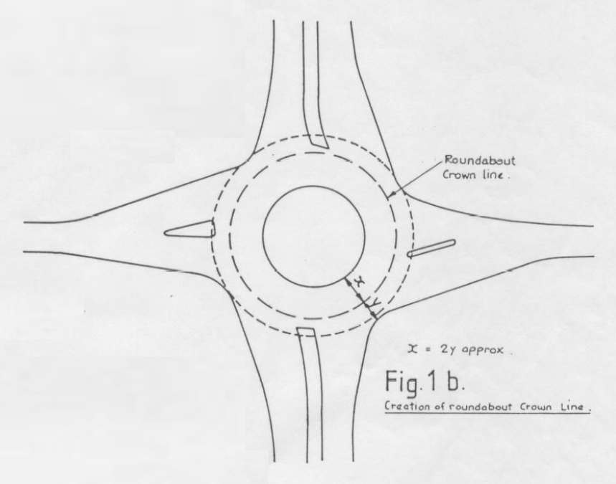

The entry and exit crown lines can also be constructed. These should be smooth curves between the centre lines of the legs and the roundabout crown line (Figure 1c).

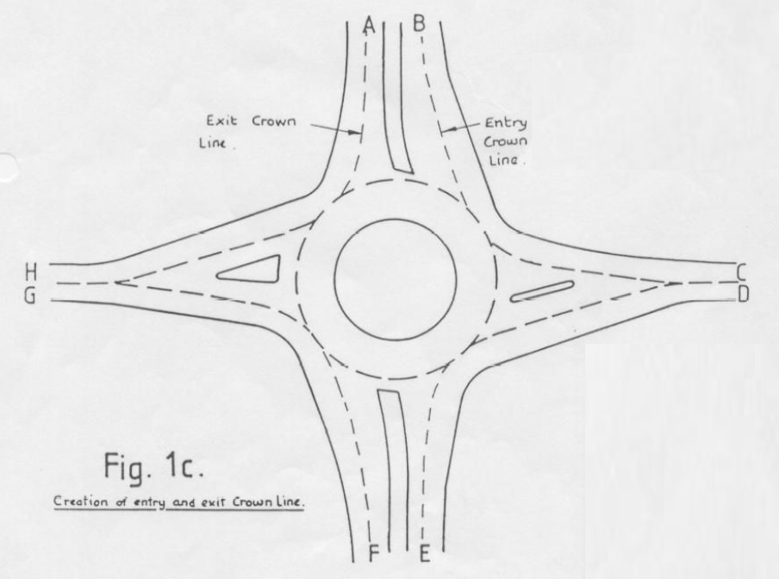

Do this for each of the legs of the roundabout. It is essential that the entry crown line of one leg does not overlap with the exit crown line of the next leg (Figure 1d).

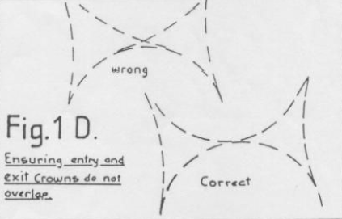

The exact position of these crown lines is not important although as a guide they should be approximately parallel with the outer kerb lines. It should be borne in mind that a longitudinal joint in the surfacing will have to be formed along this line.

Vertical Design of Crown Profiles

Ascribe one of the points where an entry crown touches the roundabout crown line a chainage of zero. Then, proceeding clockwise, mark off the roundabout crown at 5m intervals. The exit crown lines can be allocated chainages in a similar manner using the same chainage base as the crown line. The entry crowns are also ascribed chainages but they have to increase as the entry crown approaches the roundabout so to ensure that the entry crown chainage matches that of the roundabout crown line, it must be calculated backwards. Sometimes this produces negative chainages. A typical crown line layout is shown (Figure 2) with kerb lines omitted for the sake of clarity. The possible combinations of entry and exits are great but all of them can now be combined on one long section as follow:-

Draw a long section with the horizontal scale covering the whole range of chainages on the crown lines. The vertical scale should incorporate all the levels to be dealt with. Mark on the long section the levels and gradients of each entry leg. Note: each single carriageway will have two positions on the graph, one for the entry crown and one for the exit crown (Figure 3a), and, in the case of a single carriageway the levels will be identical, the gradients will be equal but arithmetically opposite (i.e. one gradient will be +ve and one -ve), but the chainages will be dissimilar.

The next step is to draw in a suggested profile along the roundabout crown. Chainage zero and the last chainage on the roundabout crown are, in fact, the same point so the level and gradient must be kept the same. With experience the engineer can pick a suitable compound curve but to start with smooth curves should be drawn connecting each entry to the next exit. The points where the roundabout crown must touch these curves can be marked on them and a roundabout crown profile can then be sketched in between these curves (Figure 3b). It will now be apparent how the entry and exit crowns should be distorted to maximise the radius of curvature on the roundabout crown while still not making the radii on the entry and exit crowns too small (Figure 4). If two crown lines run close to one another in the horizontal plane it is important to ensure that there is no too great a difference in the levels (i.e. too steep a crossfall between).

It is vital that a motorist approaching a roundabout can “read the road” ahead. Where entry lanes rise up to a roundabout it is essential that the give way lines can be seen from a sufficient distance to permit easy stopping. This may sometimes be achieved by creating a crest on the entry road so the driver is actually on a slight downgrade at the give way line. The levels on the long section may then be transferred back onto the layout, as a series of spot levels (Figure 5).

Ancillary Levels

These can now be created by using constant crossfalls or constant level differences between the crown lines and nearby channels. By this means the channels round to the outside of the roundabout and the central island channel levels can be fixed. Ensure that the central island kerb does not go through too great a variation in level. Should it do so, the crown line should be “flattened”. This will reduce the degree of variation in the kerb line levels.

Deflection islands are inevitably surrounded by three crown lines and should be positioned at a higher level than any of the lines, if possible. The levels at the corners should be determined first by taking a gradient up from the two crown lines opposite and creating a level which would produce an acceptable slope in each case (usually the average of the two levels, but flat spots must be avoided). The direction of these slopes is indicated in Figure 6. Unless the island is very large, intermediate levels can then be calculated by interpolation of the corner levels.

If there is no deflection island, only a single level is required, in the centre of the three-sided figure and this is obtained by taking a desirable gradient up from each side, directly opposite the centre point an averaging as before.

The crossfall from the roundabout crown towards the central island and from the entry and exit crowns towards the outer kerblines should be made about 3.33-4 per cent to provide superelevation for turning traffic. The crossfalls between deflection islands or dual carriageway central reservations and the crown lines, however, can be between 2 per cent and 7 per cent although 3.33-4 per cent are still to be preferred.

Scales

It is suggested that the horizontal layout be drawn to 1/250 or 1/200 scale. The chart below shows possible long section scales with suggested minimum radii for channels and associated railway curves for the distorted scales.

|  |  |  |  |  |
| --- | --- | --- | --- | --- |
| Suggested Long Section Scales. | Minimum Desirable Vertical Curve Radius. | Associated Railway Curve. | Absolute Minimum Vertical Curve Radius. | Associated Railway Curve. |
| 1/250 horizontal  1/25 vertical | 500m | 200mm | 100m | 40mm |
| 1/200 horizontal  1/20 vertical | 500m | 250mm | 100m | 50mm |

Maximum desirable channel gradient = 4 per cent. Absolute maximum channel gradient = 7 per cent.

To calculate vertical radii and gradients on the crown lines, the above figures must be multiplied by a factor, F:

F = R/r

where

* R = horizontal radius of crown line
* r = horizontal radius of channel

e.g. if central island radius = 12m and roundabout crown line radius = 20m, then

F = 20/12 = 1.67.

For the roundabout crown line, using 1/250 / 1/25 scale, then:

* Minimum desirable vertical curve radius = 833
* Associated railway curve = 333
* Absolute minimum vertical curve radius = 167
* Associated railway curve = 67
* Maximum desirable gradient = 6.7%
* Absolute maximum gradient = 11.7%

As a general rule, however, the radii used should be kept large and the gradients kept over 0.5 per cent for as great a distance as possible to facilitate drainage.

Computer Applications

The Crown Profile Method has been incorporated into the MOSS suite of programmes with little difficulty although it could equally be used in other highway design programmes (BIPS etc).

Basically, a separate tw0-dimensional model is created, where each crown line is represented as a straight line in the horizontal plane with a constant Northing, say, and the chainage represented by the Eastings. Vertical alignments can then be created and a long section plot produced, superimposing the crown lines upon each other.

Figure 8 shows the basic layout of a three-leg roundabout with crown lines superimposed and Figure 9 is a copy of a long section plot of a separate two-dimensional model showing the crown lines. Figure 10 is a plot of the crown line and channel levels, superimposed on the layout. For users of the MOSS suite of programmes it is intended to bring out a new technical note in the near future.